**DBMS Assignment 1**

Name – Abhijit Gawai

Roll no – 18. Batch 1

Gr no – 11810895

**RFID based shopping mall**

Objective is to manage database for RFID based shopping system. Nowadays, RFID applications have attracted a great deal of interest due to their increasing adoptions in supply chain management, logistics and security. There is huge need of RFID shopping system in today’s life. One of the challenge to establish RFID based system is to manage database of RFID tags. The better we can manage database the more features we can bring into our system.

Also customer has to pay bill at every shop separately. So we have designed system that customer has to pay bill at only once. That bill will also include parking bill.

The Database will include Customer data. The customer data will include customer name, customer number as a primary key. And also data like address and contact details. Another Entity will be of Vehicle information. Information of vehicle number and location of parking will be stored. The location will be in form of ‘C18’ like most of malls have. Vehicle parking bill will added to final bill of customer. A entity named Mall will storing information like Mall name and location. Additional data like customer’s average bill on visit to mall will also be stored to do customer analysis.

The main entity is Products which will store RFID tag no. of every product a customer buys. Price of the product will be derived as we will store price of products in database. Additional information like product name and category will also be stored. This will also help to do customer analysis. We can show advertisement to customer based on his analysis. One more thing we can do is storing location of shop and product, which will help customer to locate particular product in mall.

Entity named Bill will be storing total bill. This will create very ease to customer as they will have to pay bill only once. Generally customer has to pay bill at each shop. Which is very time consuming. So customer time is saved. As we have customer details of phone number we can send bill on their phone number. Also we can request money through UPI. Customer have to just pay bill on just one tap.

Updated ER diagram:

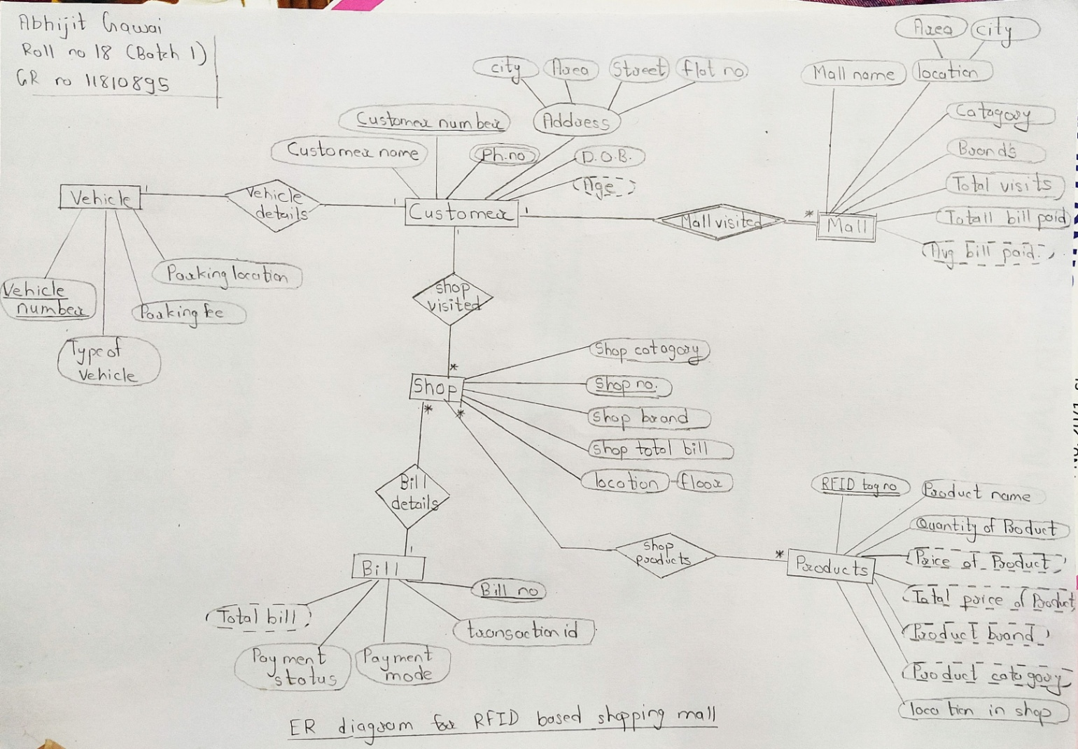

.

.

.

.

.

.

.

.

Checked ER diagram:

